Project: Pixel Pulse. – Launch of a digital magazine dedicated to retro gaming and hardware preservation.
Main Objective: To publish the inaugural 50-page digital issue and launch the accompanying web platform with a searchable hardware database.
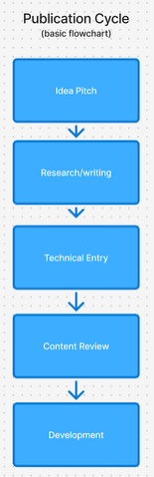
This Flowchart shows how an article is developed for the online magazine. It begins with the writer (Charlie) pitching the article to the team. Researching and writing (Developing the content) followed by entering the article into the magazine by the editor and chief. (Ellie) Then being developed into the website by the front end and back end devs.

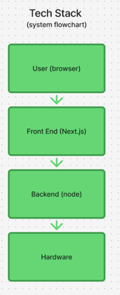
This shows a simple flow of the tech stack. The end user’s browser connects to the website, and navigates through the front end by Sally, which is built on the back end code by Lucy, which is powered by the hardware that Snoopy oversees.
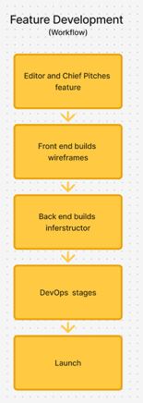
This is how new features are made, it follows a similar path to the Tech stack, as a new feature is introduced by the editor and chief (Ellie) pitches a feature to the team it moves through the order the tech does. First front end (Sally) builds the visual identity, back end builds the code then dev ops makes sure its all up and running. Then there is a launch.
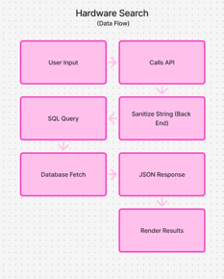
This data flow is a simple, the user searches something like “Nintendo Gamecube” the search API sends it to be satanized by the back end to avoid SQL injections and transform into an SQL queary, that goes to the database that renders it to a JSON and then bam, that goes to the end user.

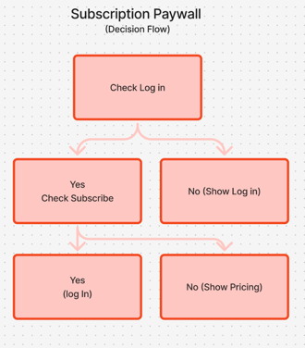
This is a simple choice flow chart, it shows the process for logging in. First the system checks if the user is logged in, if they aren’t it shows the log in page. If they are logged in, it checks to see if they are subscribed, if they are it takes them to the magazine, if not it shows pricing.

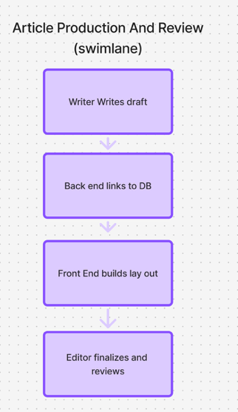
This shows how the process moves from lane to lane, it starts with writing the article (Lane one) moves to Back end to implement (Lane two) Front End styles it (Lane Three) then it is passed off to be reviewed (Lane four) this way it does not get stuck and can easily move from one to the other, each handing off at key points

